UNITED STATES

SECURITIES AND EXCHANGE COMMISSION
Washington, D.C. 20549

Form 6-K

REPORT OF FOREIGN PRIVATE ISSUER PURSUANT TO RULE 13a-16 OR 15d-16 UNDER THE

SECURITIES EXCHANGE ACT OF 1934

For the month of February 2026

Commission File Number: 001-42459

DIGINEX LIMITED

(Exact name of Registrant as specified in its charter)

Not Applicable

(Translation of registrant’s name into English)

25 Wilton Road, Victoria

London

Greater London

SW1V 1LW

United Kingdom

(Address of principal executive office)

Indicate by check mark whether the registrant files or will file annual reports under cover of Form 20-F or Form 40-F.

Form 20-F ☒ Form 40-F ☐

Indicate by check mark if the registrant is submitting the Form 6-K in paper as permitted by Regulation S-T Rule 101(b)(1): ☐

Indicate by check mark if the registrant is submitting the Form 6-K in paper as permitted by Regulation S-T Rule 101(b)(7): ☐

Entry into a Reseller Agreement with Resulticks

Diginex Limited (“Diginex” or the “Company”) and Resulticks Global Companies Pte Limited (“Resulticks”), a globally recognized leader in real-time, AI-driven customer engagement and data management solutions, entered into a reseller agreement, dated February 18, 2026 (the “Reseller Agreement”). The Reseller Agreement is for a term of four (4) years and projects targeted sales for Diginex of US$40 million in cumulative revenue over the next four years. The Reseller Agreement is expected to generate significant recurring revenue and to accelerate Diginex’s global expansion in high-growth markets.

Pursuant to the Reseller Agreement, Resulticks will actively resell Diginex’s flagship ESG and sustainability platforms to Resulticks’ broad enterprise client base spanning retail, consumer goods, technology, financial services, and beyond. Diginex believes by leveraging Resulticks’ established presence in the United States, South-East Asia, the Middle East, and India, the Reseller Agreement positions Diginex to rapidly capture demand for integrated ESG compliance and data-driven sustainability tools amid tightening global regulations and rising stakeholder expectations. Resulticks shall receive a commission equal to 15% of the annual fee of the Diginex license sold for first year’s license and 7% of the annual fee of the Diginex license sold for retaining term of the license. Diginex has also agreement to pay or reimburse Resulticks for market development activities.

The foregoing description of the Reseller Agreement does not purport to be complete and is qualified in its entirety by the terms and conditions of the actual Reseller Agreement, a copy of which is included attached hereto as Exhibit 10.1, and incorporated herein by reference.

On February 19, 2026, Diginex issued a press release disclosing the signing of the Reseller Agreement. A copy of the February 19, 2026 press release is attached hereto as Exhibit 99.1.

Entry into an Agreement with Resulticks to Restructure the repayment of US$8 million in Funding

Diginex and Resulticks entered into an agreement, dated February 18, 2026 (the “Funding Repayment Agreement”), pursuant to Resulticks agreed to repay the existing US$8 million funding Diginex extended to Resulticks (the “Existing Funding”) in four equal instalments of US$2 million each (each a “Principal Instalment”) on the following dates: (a) March 20, 2026; (b) June 1, 2026; (c) June 15, 2026; and (d) September 30, 2026. Interest shall continue to accrue on the Existing Funding in accordance with the parties original agreement (the “Interest”) at a rate of ten (10) per cent per annum from the respective date of disbursement of each portion of the Existing Funding, to the date on which such portion is repaid as a Principal Instalment as contemplated above. The entire outstanding and accrued Interest (including the portion of the Interest accrued up to and including the date of the payment of the final Principal Instalment) shall be paid in a single tranche (the “Final Interest Payment”) on September 30, 2026.

The foregoing description of the Funding Repayment Agreement does not purport to be complete and is qualified in its entirety by the terms and conditions of the actual Funding Repayment Agreement, a copy of which is included attached hereto as Exhibit 10.2, and incorporated herein by reference.

On February 19, 2026, Diginex issued a press release disclosing the signing of the Funding Repayment Agreement. A copy of the February 19, 2026 press release is attached hereto as Exhibit 99.1.

Exhibit No. |  |  | Description
 | 10.1 |  | Reseller Agreement, dated February 18, 2026, by and between Diginex Limited and Resulticks Global Companies Pte Limited.
10.2 |  |  | Funding Repayment Agreement, dated February 18, 2026, by and between Diginex Limited and Resulticks Global Companies Pte Limited.
99.1 |  |  | Diginex Limited Press Release, dated February 19, 2026.

SIGNATURES

Pursuant to the requirements of the Securities Exchange Act of 1934, the registrant has duly caused this report to be signed on its behalf by the undersigned, thereunto duly authorized.

DIGINEX LIMITED
Date: February 27, 2026 | /s/ Lubomila Jordanova
Name: | Lubomila Jordanova
Title: | Chief Executive Officer
 | (Principal Executive Officer)

Exhibit 10.1

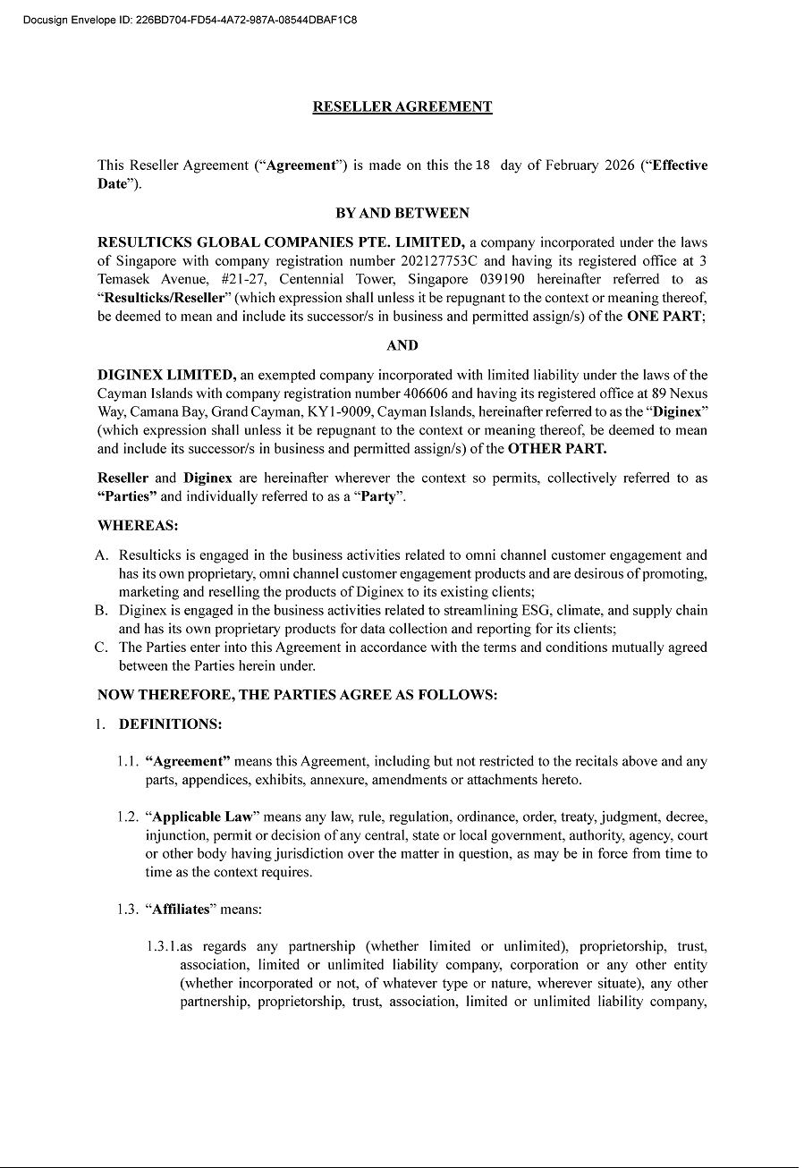

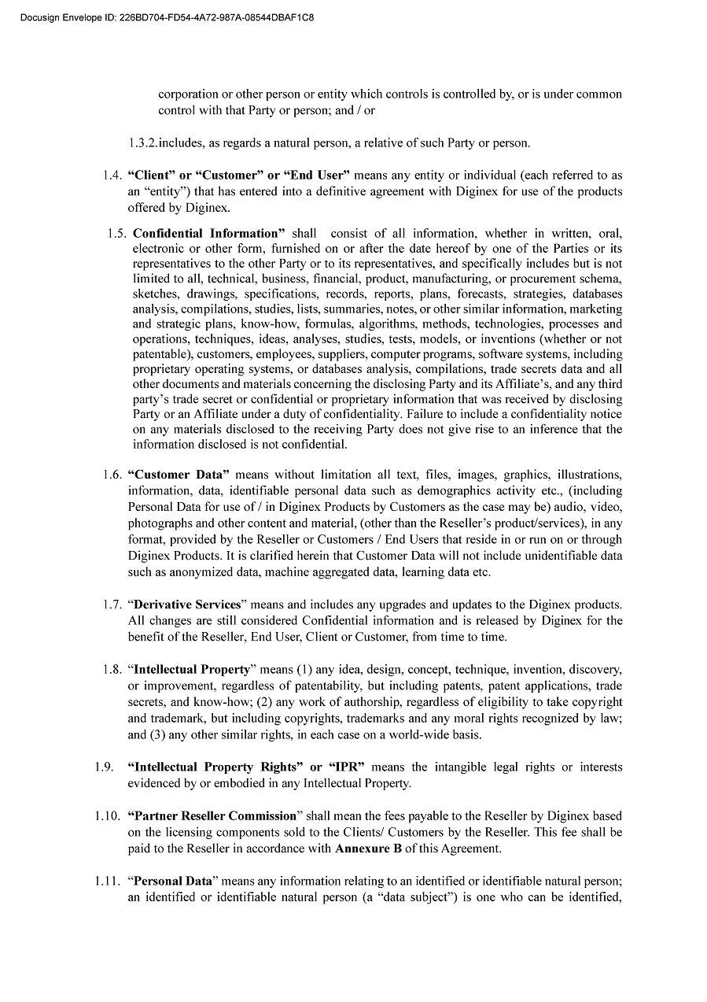

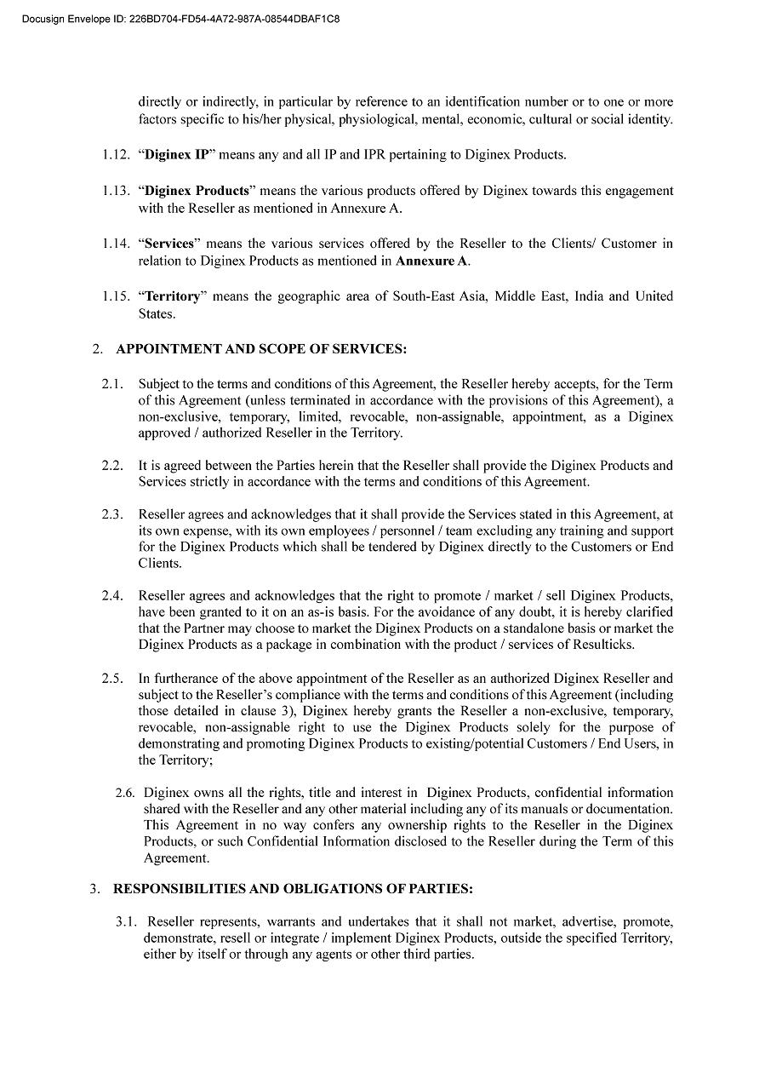

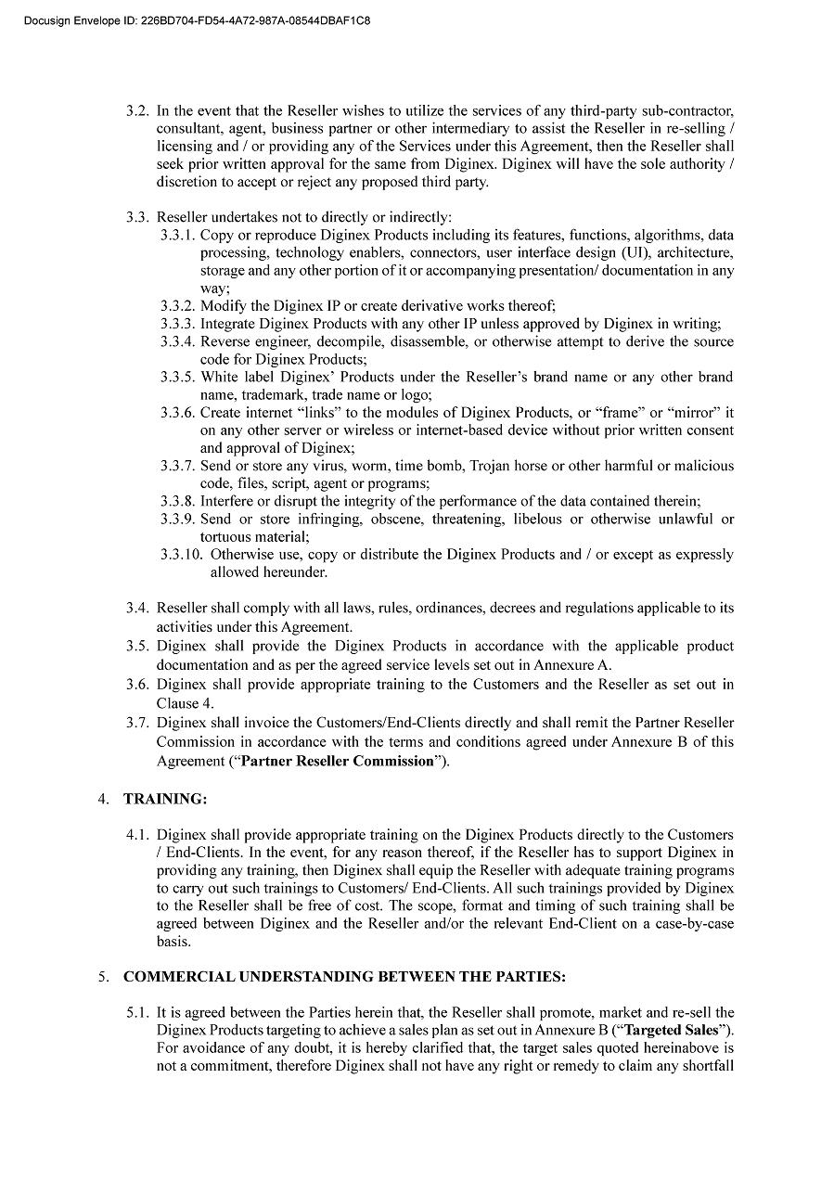

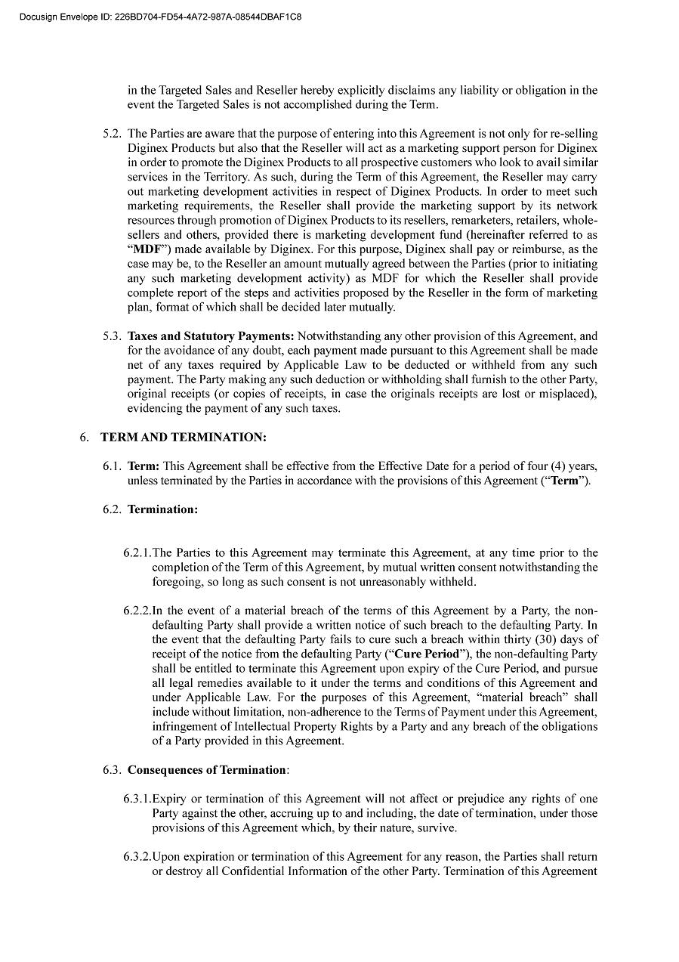

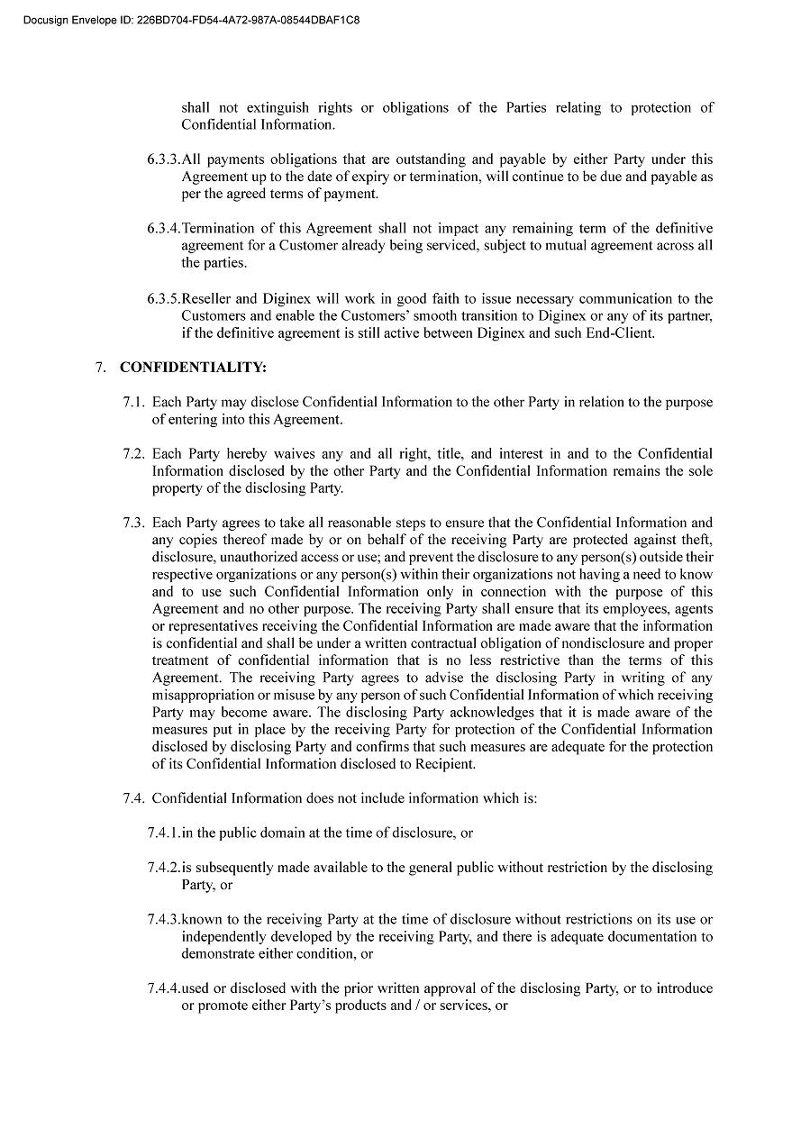

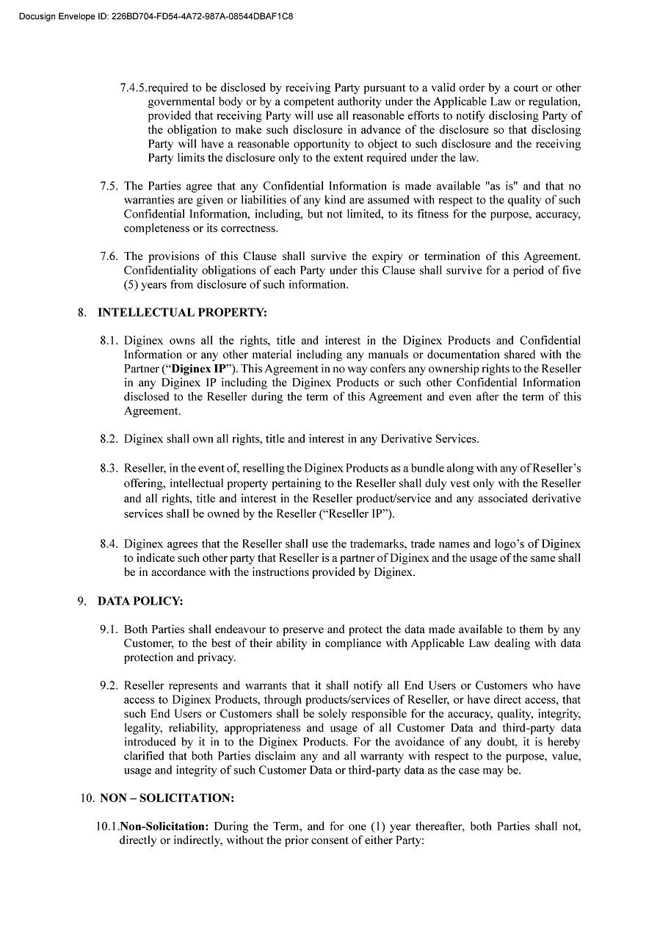

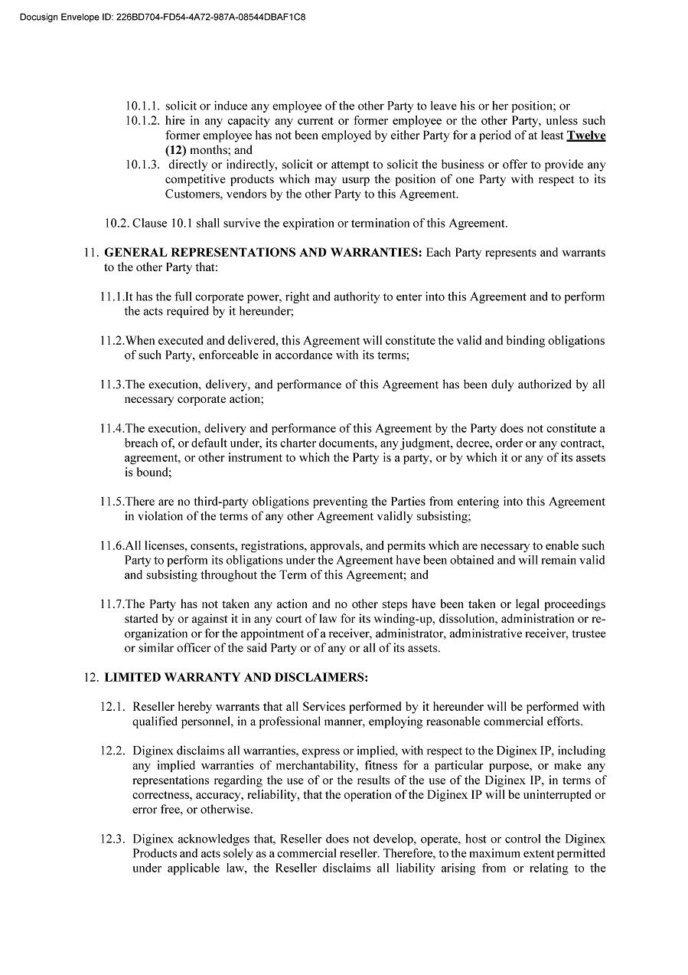

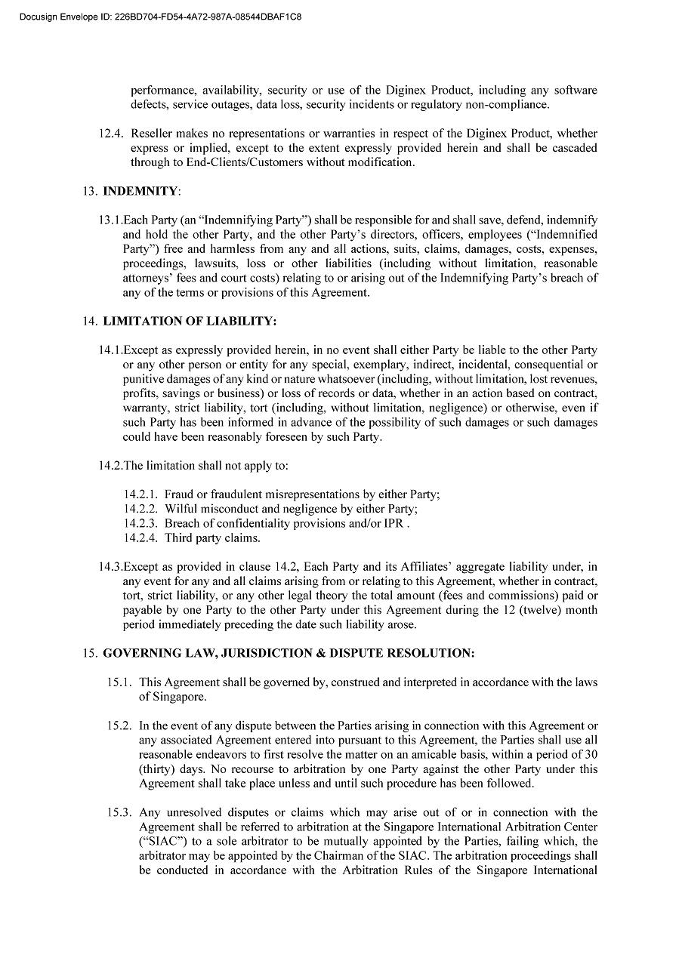



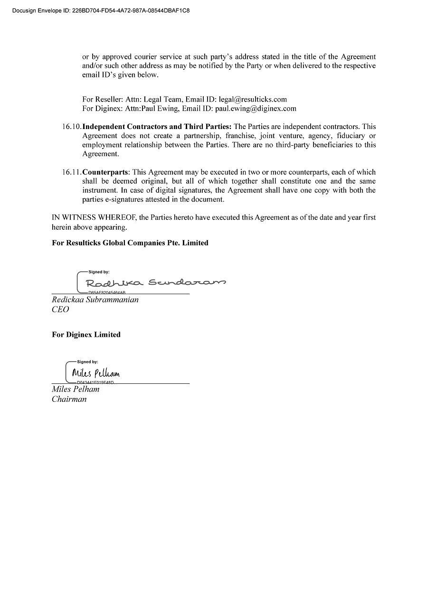

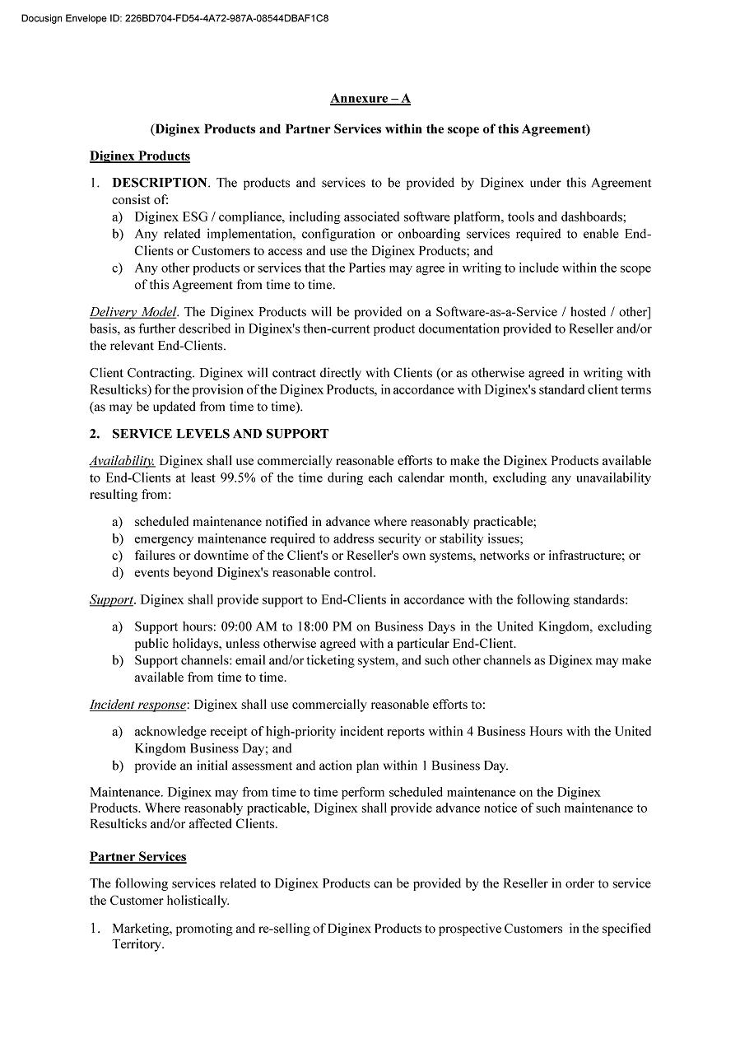

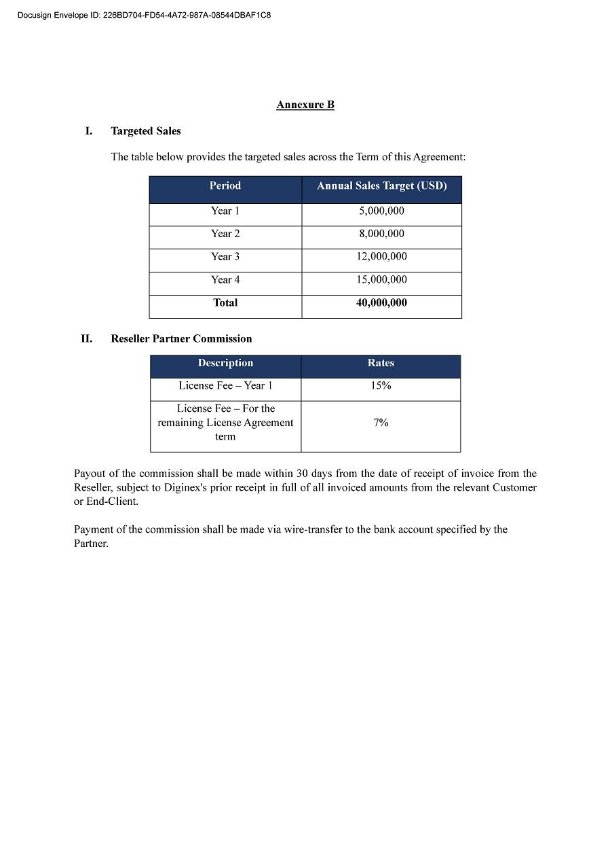

Exhibit 10.2



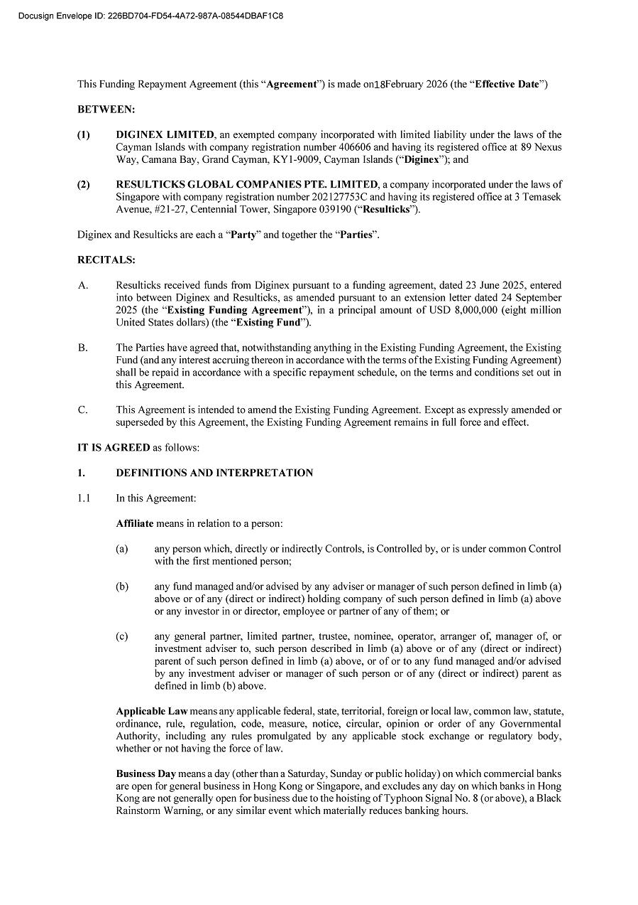

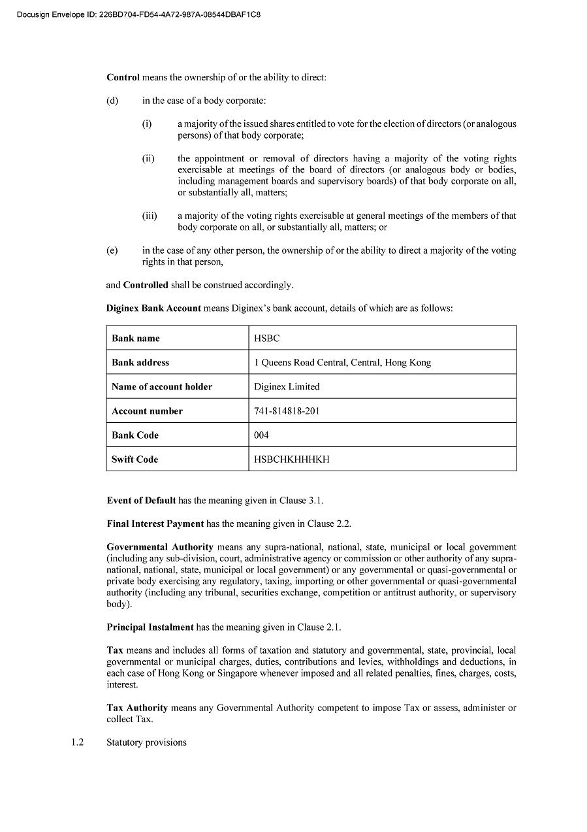

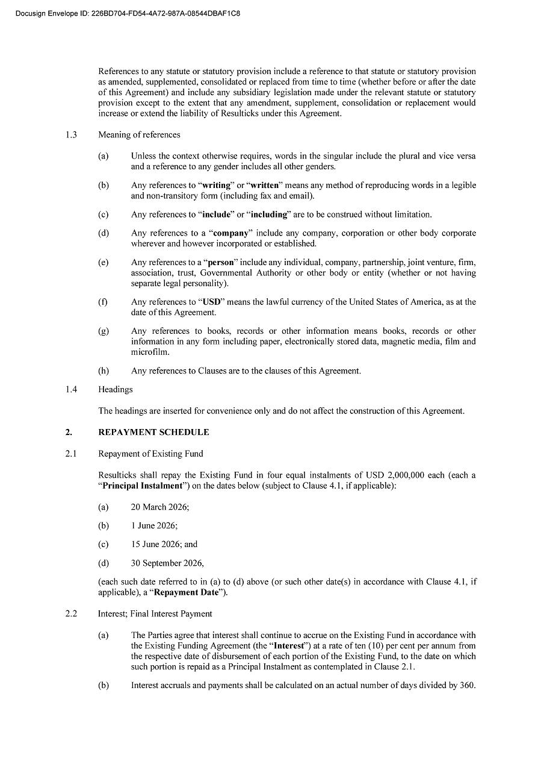

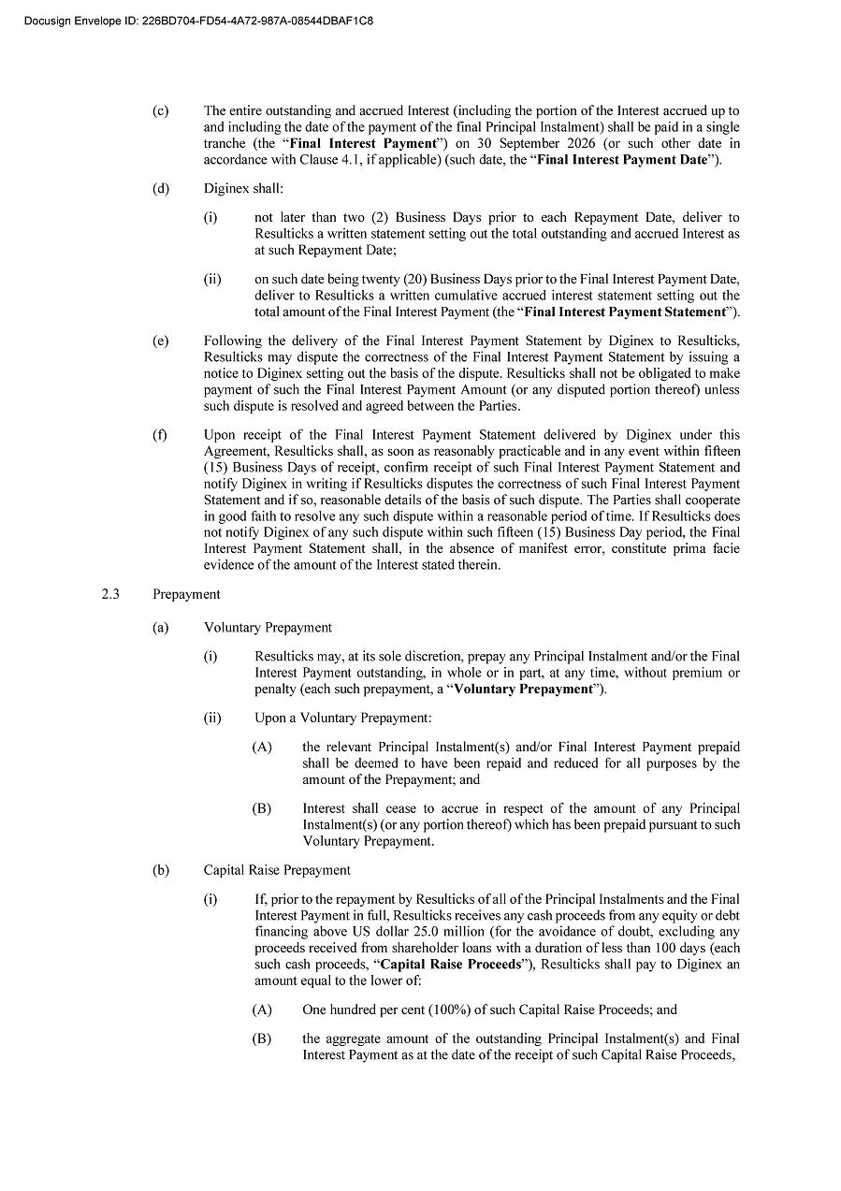

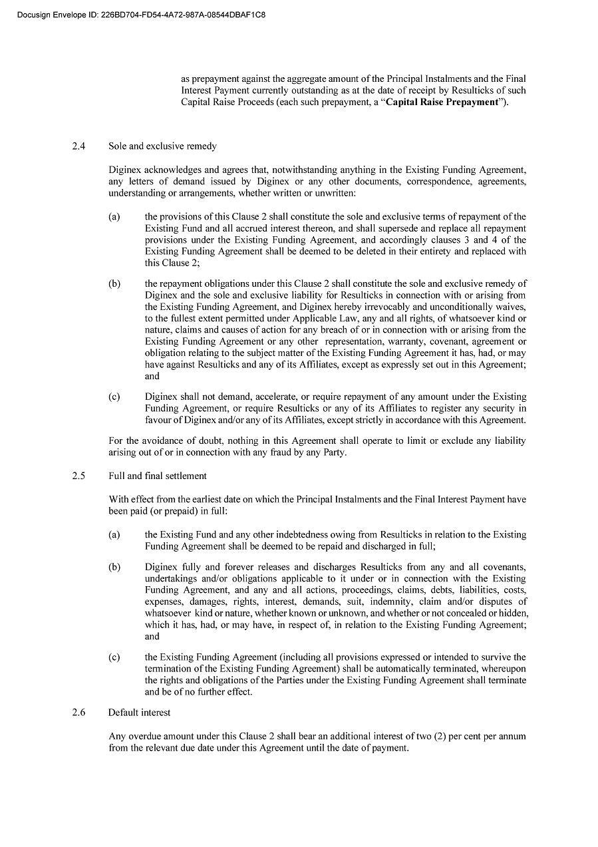



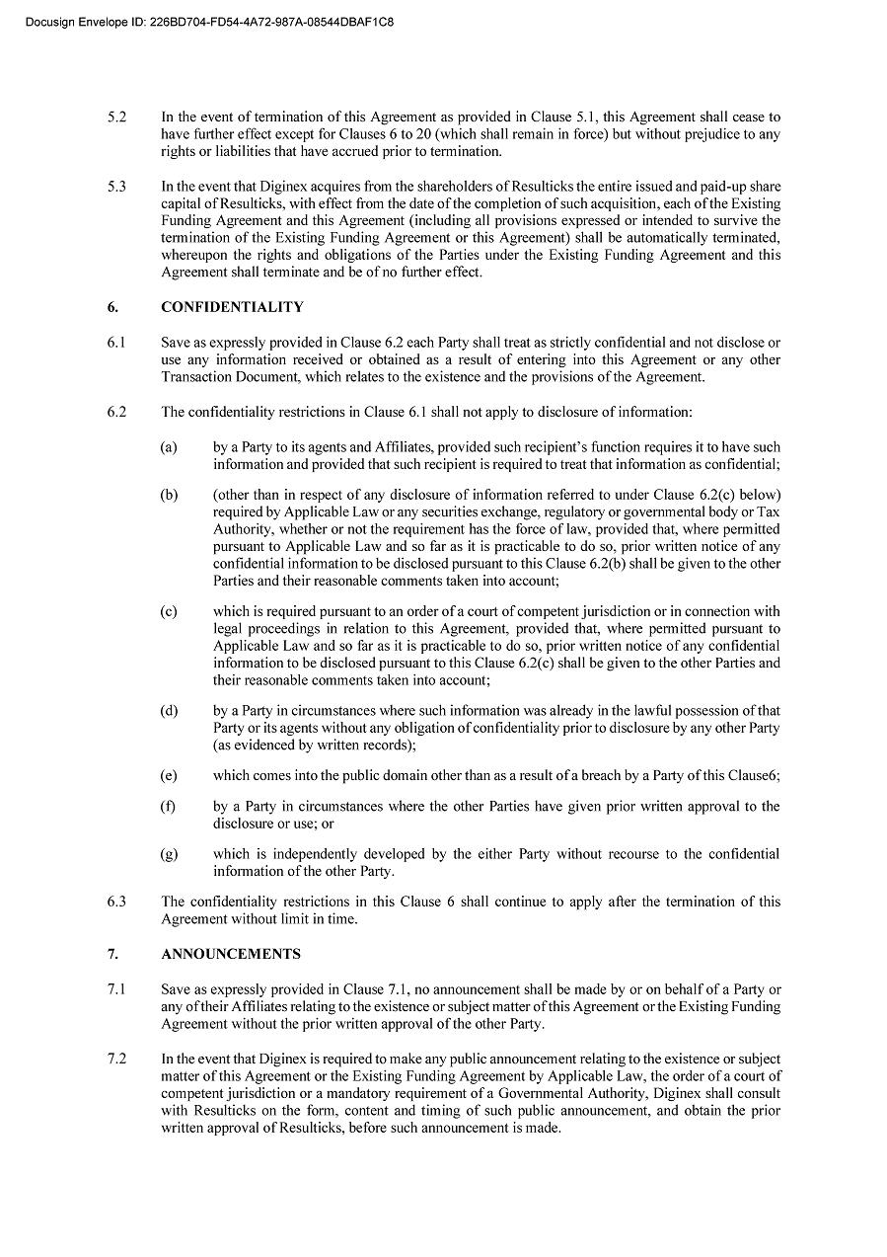

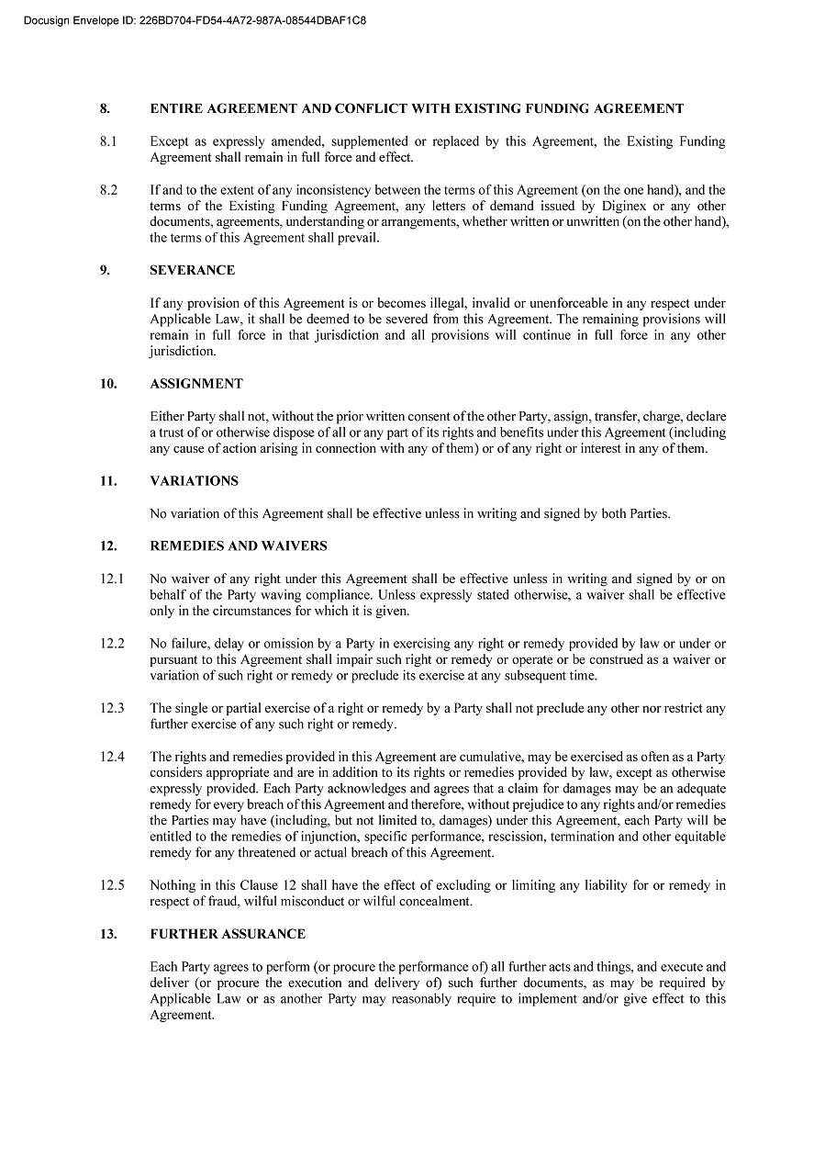

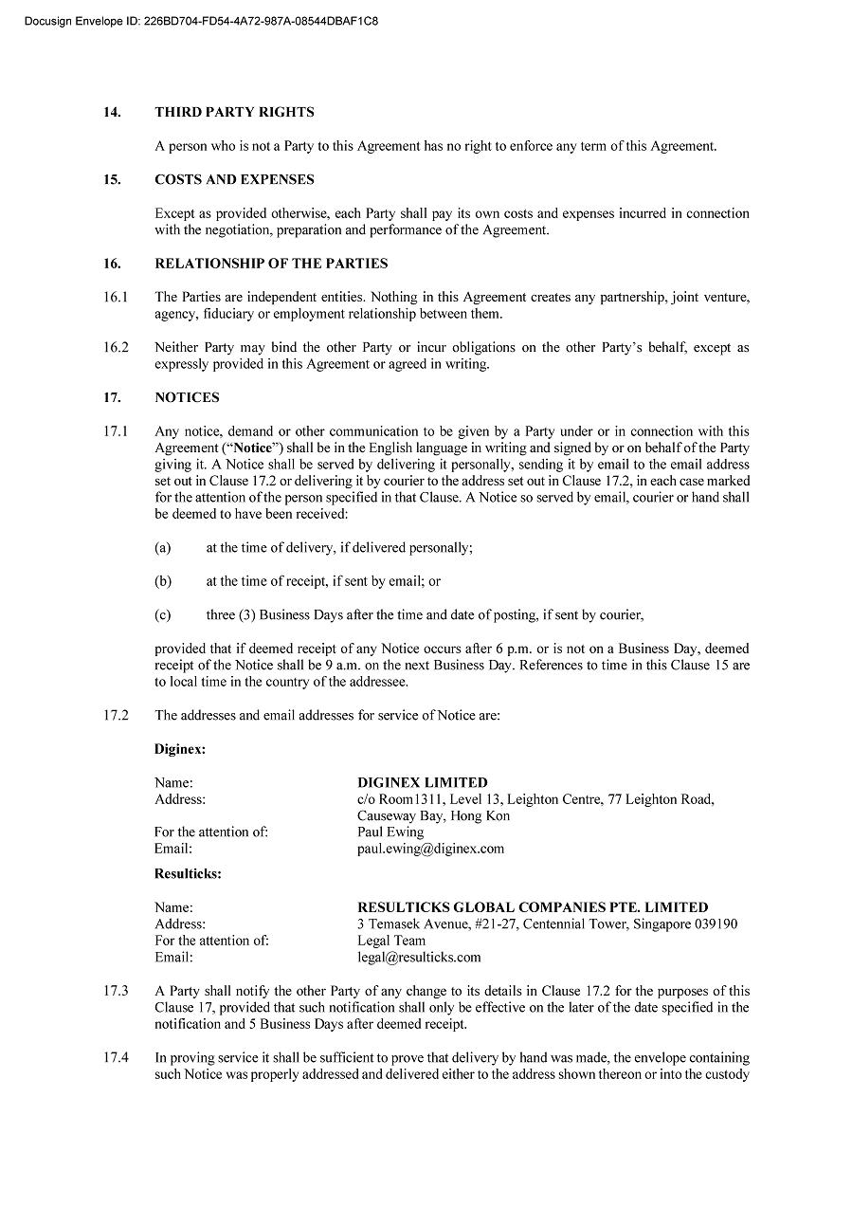

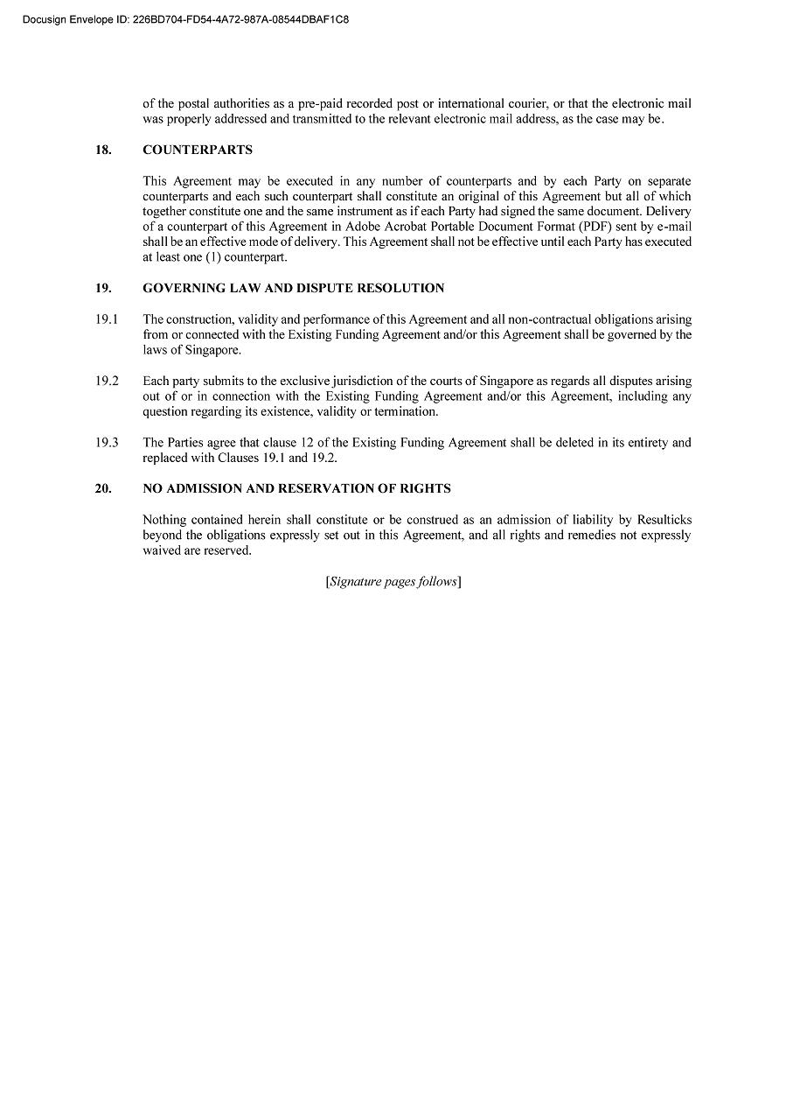





Exhibit 99.1

Diginex Limited (Nasdaq: DGNX) Secures Transformative Reseller Agreement with Resulticks Targeting US$40 Million in Revenue Over Four Years – Strengthening Path to Strategic Combination and Shareholder Value Creation

LONDON, United Kingdom – February 19, 2026 – Diginex Limited (NASDAQ: DGNX), a leading provider of Sustainability RegTech solutions empowering businesses and governments with advanced ESG, climate, and supply chain data management tools, today announced the execution of a major strategic reseller agreement with Resulticks Global Companies Pte Limited (“Resulticks”), a globally recognized leader in real-time, AI-driven customer engagement and data management solutions. This high-impact strategic relationship targets US$40 million in cumulative revenue over the next four years (the “Reseller Agreement”), delivering significant recurring revenue potential and accelerating Diginex’s global expansion in high-growth markets.

Under the Reseller Agreement, Resulticks will actively resell Diginex’s flagship ESG and sustainability platforms to its broad enterprise client base spanning retail, consumer goods, technology, financial services, and beyond. By leveraging Resulticks’ established presence in the United States, South-East Asia, the Middle East, and India, we believe the Reseller Agreement positions Diginex to rapidly capture demand for integrated ESG compliance and data-driven sustainability tools amid tightening global regulations and rising stakeholder expectations.

The Reseller Agreement establishes a strong foundation for even greater value creation deepening technical and operational integration—uniting Diginex’s advanced ESG data platforms with Resulticks’ powerful AI engagement engine – creating integrated data flows, real-time analytics, and unified offerings that convert sustainability intelligence into personalized, scalable customer activations. We believe these synergies, including amplified AI capabilities, expanded market reach, robust cross-selling channels, and accelerated innovation in AI-powered ESG solutions position this alliance as a global frontrunner in the convergence of sustainability RegTech and intelligent customer data management.

As part of this deepened strategic relationship, the parties have also successfully restructured the existing US$8 million funding Diginex extended to Resulticks pursuant to the agreement executed between Resulticks and Diginex on 23 June 2025. The restructured terms feature four equal payments of US$2 million to be made by Resulticks to Diginex by the end of September 2026 – providing clear visibility, supporting ongoing collaboration, and reinforcing financial alignment between the parties.

Miles Pelham, Chairman & Founder of Diginex, commented: “This landmark Reseller Agreement with Resulticks marks a pivotal milestone in Diginex’s growth trajectory. The US$40 million sales target over four years highlights tremendous market momentum for our integrated ESG solutions and opens substantial new revenue streams with minimal incremental cost. Combined with the strong synergies and clear path toward a potential strategic business combination, this partnership significantly enhances Diginex’s competitive position, accelerates our global scale, and creates compelling long-term value for shareholders.”

Redickaa Subrammanian, Co-Founder and CEO of Resulticks, added: “Collaborating with Diginex empowers us to deliver truly differentiated, future-ready solutions that fuse world-class customer engagement with best-in-class ESG compliance and reporting. In today’s market, sustainability drives brand value and performance—this agreement enables our clients to transform ESG data into powerful commercial advantages, and we are excited to drive mutual success through this strategic alliance.”

The Reseller Agreement is effective immediately, with joint go-to-market initiatives, marketing campaigns, sales enablement, and customer onboarding programs already underway to capitalize on this opportunity.

M&A Update

Diginex remains in active and constructive dialogue with Resulticks to conclude the potential business combination transaction, with final terms to the transaction now agreed. The parties remain in active discussion with several providers for a non-dilutive medium-term debt facility in order to close the transaction.

While Diginex is hopeful of concluding the potential business combination transaction with Resulticks, there can be no assurance that the parties will ultimately execute the definitive transaction agreement or close the proposed business combination transaction.

About Diginex

Diginex Limited (Nasdaq: DGNX; ISIN KYG286871044), headquartered in London, is a sustainable RegTech business that empowers businesses and governments to streamline ESG, climate, and supply chain data collection and reporting. The Company utilizes blockchain, AI, machine learning and data analysis technology to lead change and increase transparency in corporate regulatory reporting and sustainable finance. Diginex’s products and services solutions enable companies to collect, evaluate and share sustainability data through easy-to-use software.

The award-winning diginexESG platform supports 19 global frameworks, including GRI (the “Global Reporting Initiative”), SASB (the “Sustainability Accounting Standards Board”), and TCFD (the “Task Force on Climate-related Financial Disclosures”). Clients benefit from end-to-end support, ranging from materiality assessments and data management to stakeholder engagement, report generation and an ESG Ratings Support Service.

For more information, please visit the Company’s website: https://www.diginex.com/.

About Resulticks

Resulticks is a leading provider of AI-powered, omnichannel customer engagement and data management solutions. Its platform enables businesses to deliver personalized experiences through real-time data analytics and automation, serving clients across industries in North America, Asia, and the Middle East. Resulticks is headquartered in New York, with additional offices in India, Singapore, and Dubai.

For more information, please visit the Resulticks website: https://resulticks.com/

Forward-Looking Statements

Certain statements in this announcement are forward-looking statements. These forward-looking statements involve known and unknown risks and uncertainties and are based on the Company’s current expectations and projections about future events that the Company believes may affect its financial condition, results of operations, business strategy and financial needs. Investors can identify these forward-looking statements by words or phrases such as “approximates,” “believes,” “hopes,” “expects,” “anticipates,” “estimates,” “projects,” “intends,” “plans,” “will,” “would,” “should,” “could,” “may” or other similar expressions. The Company undertakes no obligation to update or revise publicly any forward-looking statements to reflect subsequent occurring events or circumstances, or changes in its expectations, except as may be required by law. Although the Company believes that the expectations expressed in these forward-looking statements are reasonable, it cannot assure you that such expectations will turn out to be correct, and the Company cautions investors that actual results may differ materially from the anticipated results and encourages investors to review other factors that may affect its future results disclosed in the Company’s filings with the SEC.

Diginex

Investor Relations

Email: ir@diginex.com

IR Contact - Europe

Anna Höffken

Phone: +49.40.609186.0

Email: diginex@kirchhoff.de

IR Contact - US

Jackson Lin

Lambert by LLYC

Phone: +1 (646) 717-4593

Email: jian.lin@llyc.global

